SIMATS ENGINEERING
ASSESSMENT TOOL 2

COURSE NAME: Fundamentals of Data Science COURSE CODE: DSA04

COURSE OUTCOME COVERED
CO1: Analyse the role of data science, facets of data, and the big data ecosystem for informed
decision-making. (BL4)

QUESTIONS: 05 Total Marks:100

Annexure A
CONCEPT MAPPING

Code of Conduct:
I G Chandravardhan Reddy (192425037 ) certify that this submission is my original work and that I have adhered to the guidelines specified for this assessment. I understand that any violation of academic integrity rules will result in disciplinary action.

Signature of the student: G Chandravardhan Reddy

Annexure A
Concept Mapping
1. A college wants to analyze student performance using attendance records, internal marks,
assignment scores, and final exam results. Draw a concept map showing the Data Science
process from data collection to data transformation.
2. A hospital collects patient details from registration forms, lab reports, medical devices, and
doctor notes. Construct a concept map showing the different data collection sources and how
they are used for analysis.
3. An online shopping company finds missing customer details, duplicate orders, wrong
product entries, and unusual purchase amounts in its dataset. Draw a concept map showing
the data cleaning steps required before analysis.
4. A smart city project collects traffic data from CCTV cameras, GPS devices, sensors, and
mobile applications. Prepare a concept map showing how data from multiple sources can be
integrated into a single dataset.
5. A bank wants to prepare customer data for loan approval prediction. The dataset contains
income, age, job type, loan amount, and credit score. Draw a concept map showing suitable
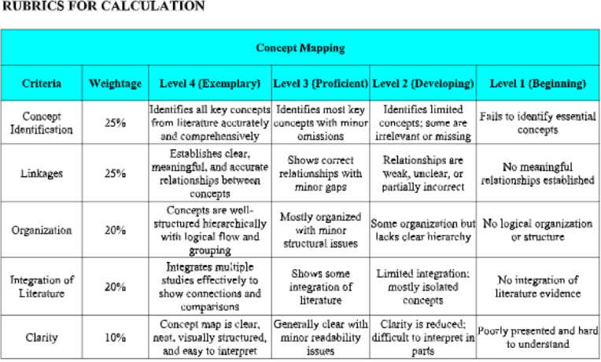
data transformation techniques such as encoding, normalization, and feature scaling.

Introduction
Every organization today, whether a college, hospital, retailer, city administration or bank, produces data all the time. Data on its own does not help anyone make a decision. It has to be collected, cleaned, combined and prepared before it can reveal patterns. Data science is the discipline that does this. It brings together statistics, programming and domain knowledge to turn raw data into knowledge that supports informed decisions.
Role of Data Science
Data science helps an organization describe what has happened, explain why it happened, predict what is likely to happen next and recommend what to do about it. A college can find which students are at risk of failing, a hospital can spot patients whose condition is worsening, and a bank can estimate whether a borrower will repay a loan. In each case the quality of the decision depends on the quality of the data preparation behind it.
Facets of Data
Data comes in many forms, and the form decides how it is collected and prepared. The main facets are:
- Structured data: organized in rows and columns, such as marks tables and registration forms.
- Unstructured data: free text, such as doctor notes and emails.
- Machine-generated and streaming data: produced automatically and continuously, such as sensor and GPS logs.
- Audio, image and video data: such as CCTV footage.
- Graph and network data: relationships between entities, such as social or road networks.

Big Data Ecosystem
When data becomes very large, arrives very fast or is very varied (volume, velocity and variety), ordinary tools are not enough. The big data ecosystem provides the tools for this: distributed storage and processing (for example Hadoop and Spark), data lakes and warehouses, NoSQL databases, ETL and streaming pipelines, and analytics and visualization tools. Several of the scenarios in this assignment, especially the smart city and hospital cases, rely on this kind of ecosystem.
The Data Science Process
A data science project normally follows these stages: (1) set the research goal, (2) retrieve or collect data, (3) prepare data by cleaning, integrating and transforming it, (4) explore the data, (5) build models, and (6) present results and automate. This assignment concentrates on the first three stages, which usually take most of the effort in real projects, because a model can only be as good as the data it learns from.
Why Concept Maps
A concept map is a diagram in which ideas are shown as boxes (concepts) joined by arrows carrying short linking phrases such as "leads to" or "gathers". Reading along an arrow gives a complete statement, so a concept map shows both the concepts and how they relate. This makes it well suited to showing a multi-step process and to analysing how the stages of data preparation depend on each other (Bloom level 4, as required by CO1).
About This Document
Annexure A contains five scenarios. For each one this document gives the concept map, followed by an explanation of the stages, techniques and reasoning behind the map. In the maps, green boxes are data sources or inputs, blue boxes are process stages, orange boxes are data problems, yellow boxes are techniques or actions, and purple boxes are outputs.
Question 1: Student Performance Analysis
Scenario
A college wants to analyze student performance using attendance records, internal marks, assignment scores and final exam results. Draw a concept map showing the Data Science process from data collection to data transformation.
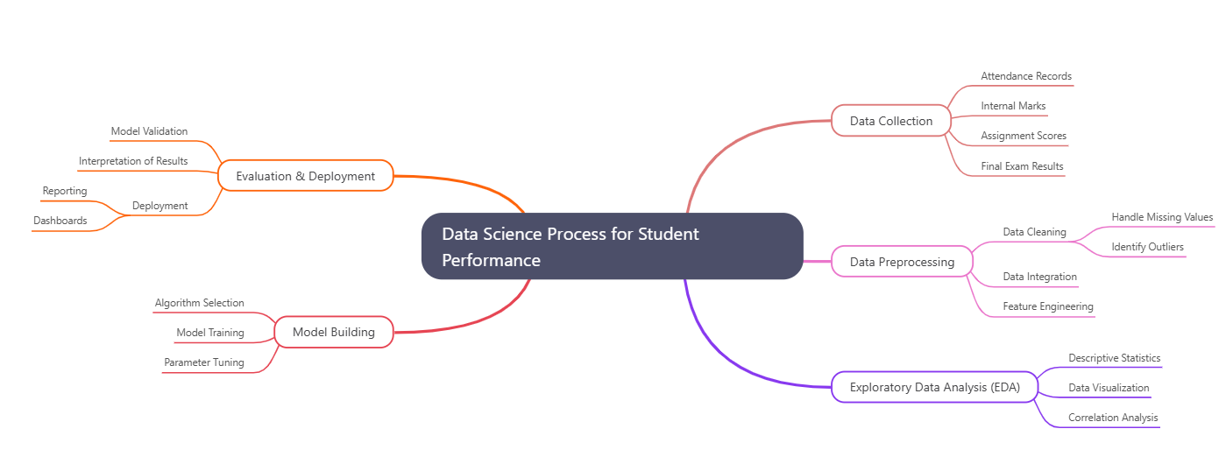
Concept Map
Figure 1: Data Science process for student performance analysis

Question 2: Hospital Data Collection Sources
Scenario
A hospital collects patient details from registration forms, lab reports, medical devices and doctor notes. Construct a concept map showing the different data collection sources and how they are used for analysis.
Concept Map
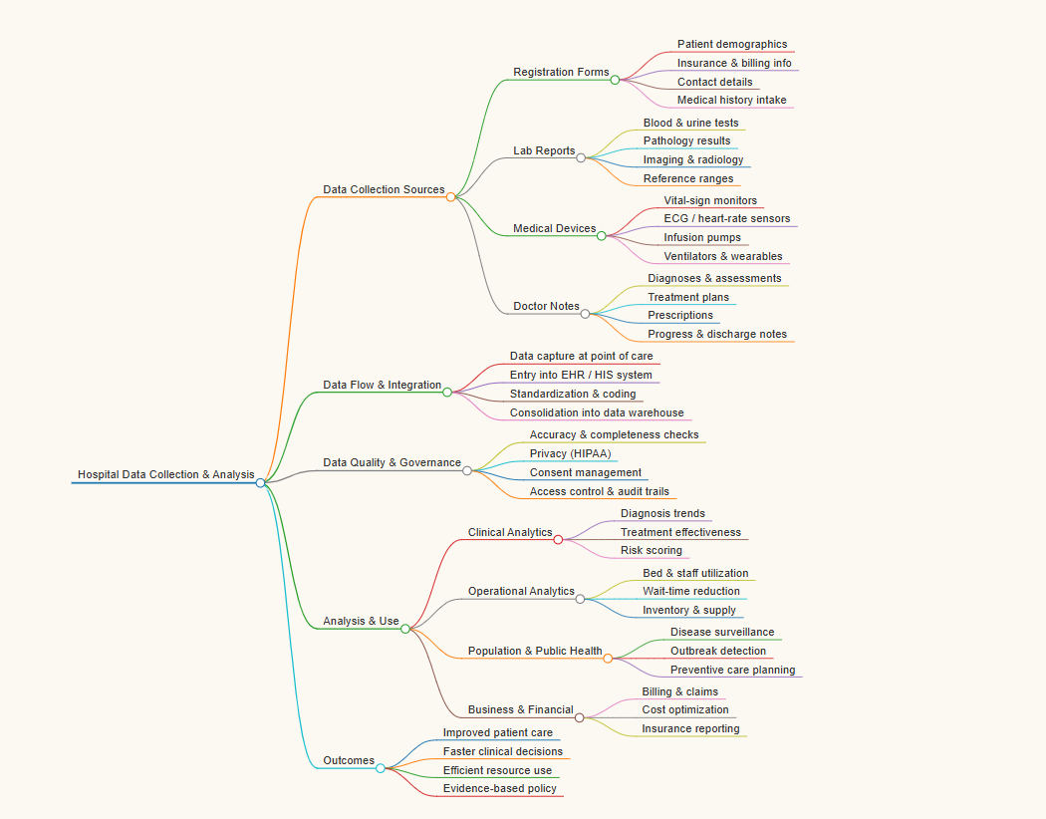
Figure 2: Hospital data sources and their use in analysis
Question 3: Data Cleaning for an Online Shopping Dataset
Scenario
An online shopping company finds missing customer details, duplicate orders, wrong product entries and unusual purchase amounts in its dataset. Draw a concept map showing the data cleaning steps required before analysis.
Concept Map

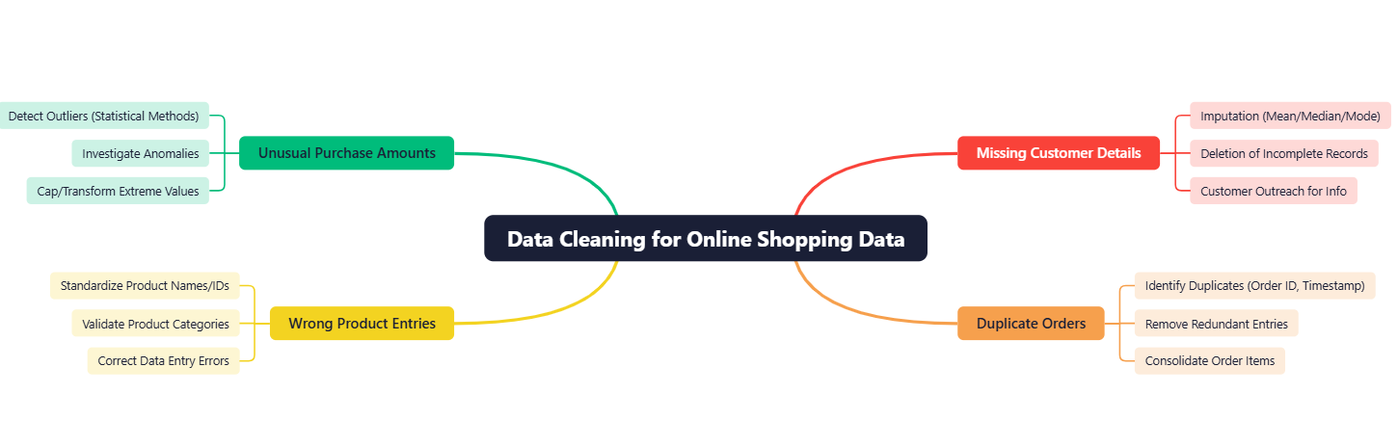
Figure 3: Data cleaning steps for the online shopping dataset
Question 4: Data Integration for a Smart City Traffic Project
Scenario
A smart city project collects traffic data from CCTV cameras, GPS devices, sensors and mobile applications. Prepare a concept map showing how data from multiple sources can be integrated into a single dataset.
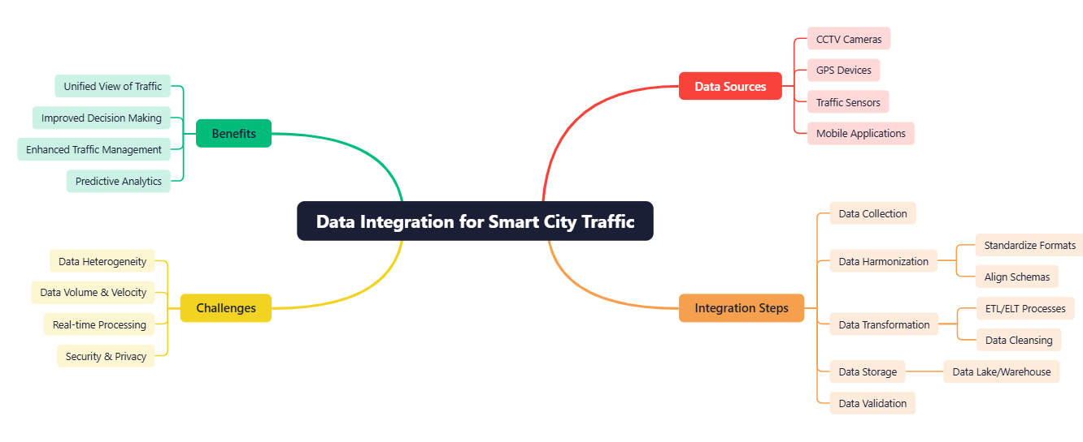
Concept Map

Figure 4: Integrating multi-source traffic data into one dataset

Question 5: Data Transformation for Loan Approval Prediction
Scenario
A bank wants to prepare customer data for loan approval prediction. The dataset contains income, age, job type, loan amount and credit score. Draw a concept map showing suitable data transformation techniques such as encoding, normalization and feature scaling.
Concept Map
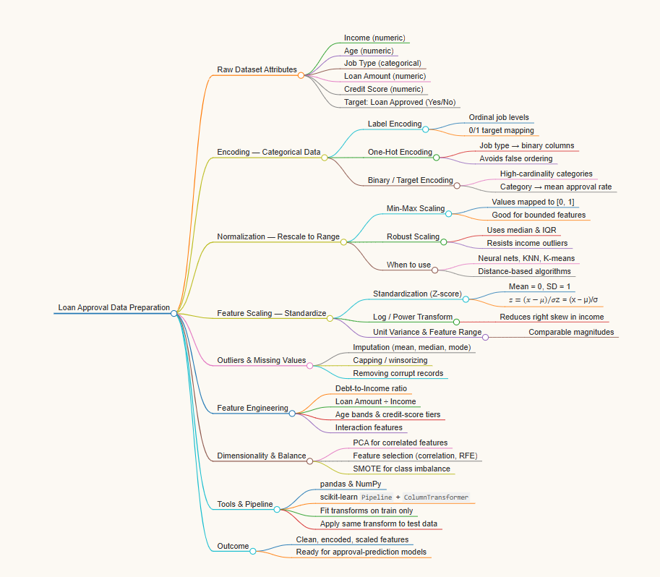
Figure 5: Data transformation techniques for loan approval data

